**Title: Traffic Light Control System Design**

**1. Introduction:**

This project focuses on designing and implementing a traffic light control system using Tinkercad, EasyEDA, and various hardware components. Traffic light control systems play a crucial role in managing traffic flow and ensuring road safety.

**2. Objective:**

The main objective of this project is to develop a functional traffic light control system that accurately simulates real-world traffic scenarios. This involves designing the circuit using Tinkercad, creating the schematic with EasyEDA, and integrating hardware components for physical implementation.

**3. Components Used:**

- Arduino UNO microcontroller

- LEDs (Red, Yellow, Green)

- Resistors

- Breadboard

- Jumper wires

- Other miscellaneous components as required

**4. Design:**

The traffic light control system was designed using Tinkercad for simulation. The schematic was created using EasyEDA to visualize the circuit layout and connections. The design ensured proper sequencing and timing of the traffic lights for efficient traffic management.

**5. Implementation:**

In Tinkercad, the designed circuit was implemented virtually to simulate real-world behavior. Hardware components were then integrated to create a physical prototype of the traffic light system. The system's functionality was tested by applying various traffic scenarios and observing the response.

**6. Testing:**

Extensive testing was conducted to validate the system's performance. This included testing different traffic light sequences, timing accuracy, and responsiveness to changes in traffic conditions. Any discrepancies between expected and observed behavior were addressed and rectified.

**7. Implementation of the circuit in TinkerCAD:**

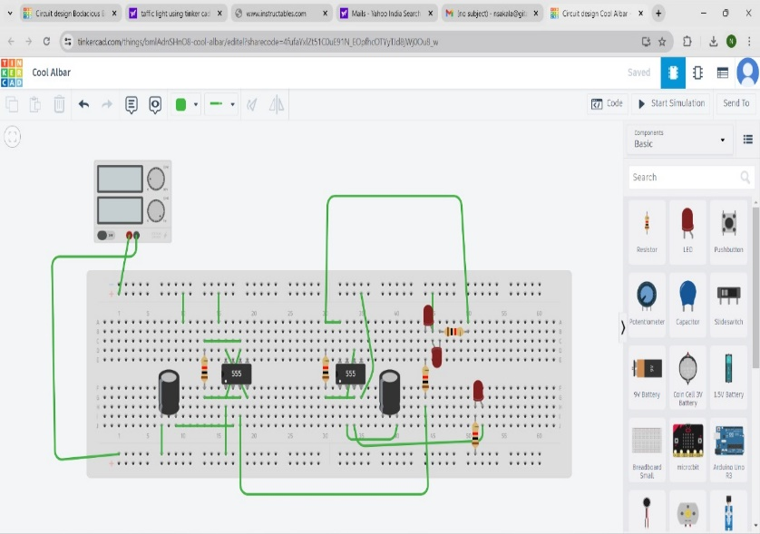

**8. PCB Designing on Easy EDA Tools:**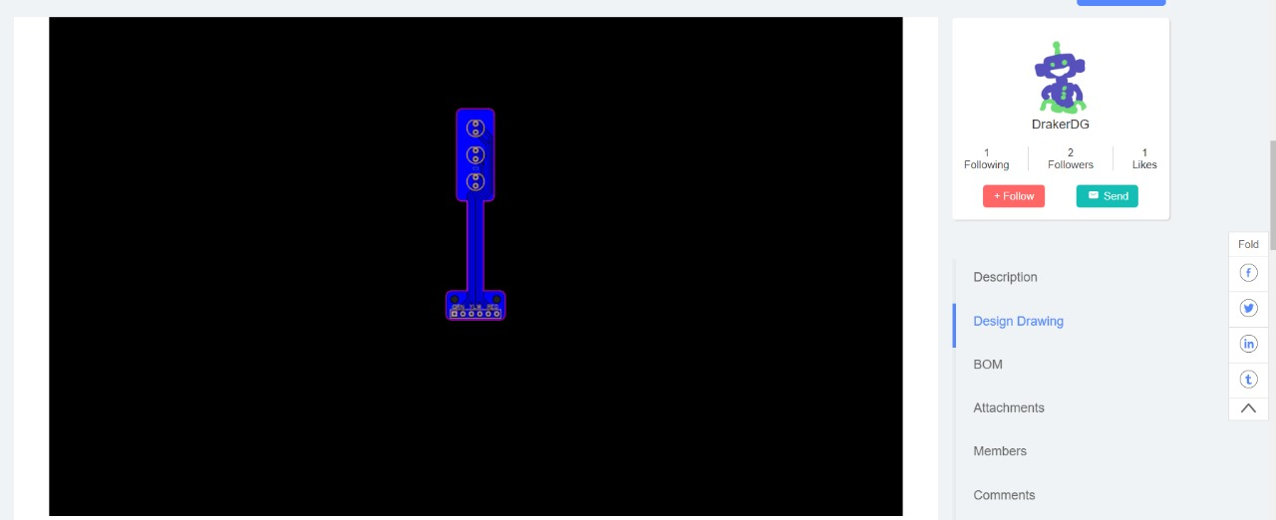

**9.Hardware implemention:**

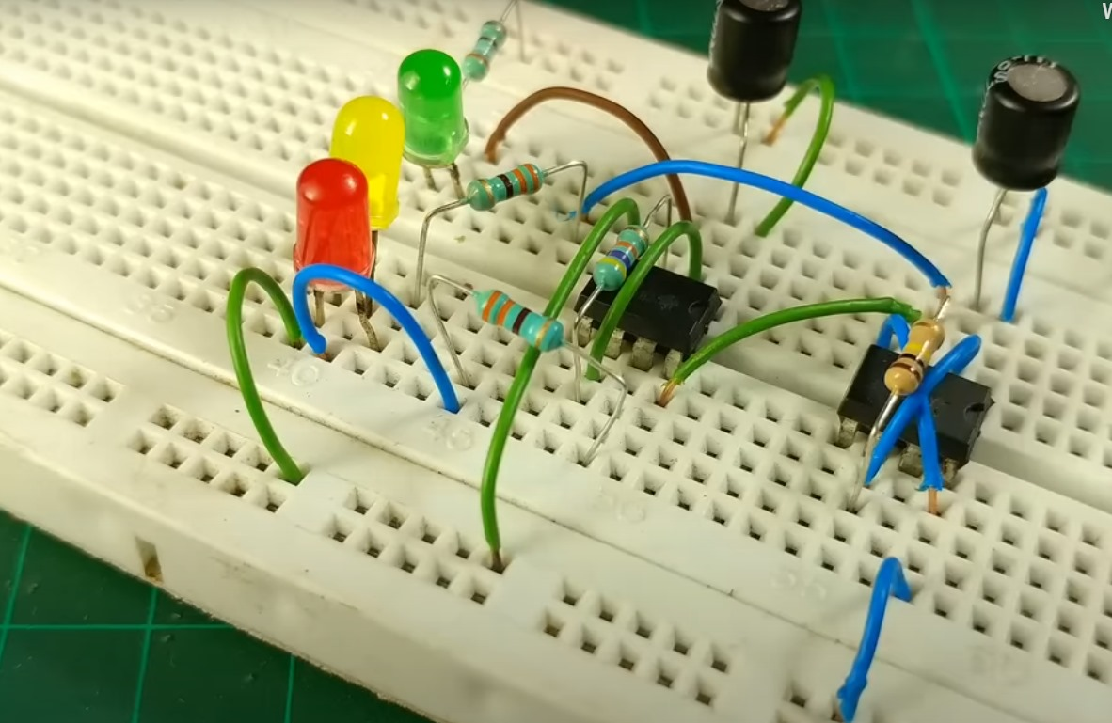

**10. Conclusion:**

The traffic light control system successfully demonstrated effective traffic management capabilities. The project highlighted the importance of simulation tools like Tinkercad and design software like EasyEDA in the prototyping process. Future enhancements could include integrating sensors for adaptive traffic control and optimizing power consumption.